SlugPath

**Sprint 1 Report**

Team Slugstras

Release Name: SlugPath Beta

Release Date: 03/22/18

Revision 1.1

2/2/18

**Actions to stop doing:**

None, everyone is working together and communicating very well.

**Actions to start doing:**

Team should work on finding a time where we can all discuss the project. This is because other than scrum meetings, we have group discussions where not everyone is present.

**Actions to keep doing:**

Communicating. Promptly responding to messages and updating why they may be late to a discussion/scrum meeting.

Meeting every MWF for scrum meetings.

Clarify on tasks being done when not clear.

Discuss what others are doing.

**Work completed/not completed:**

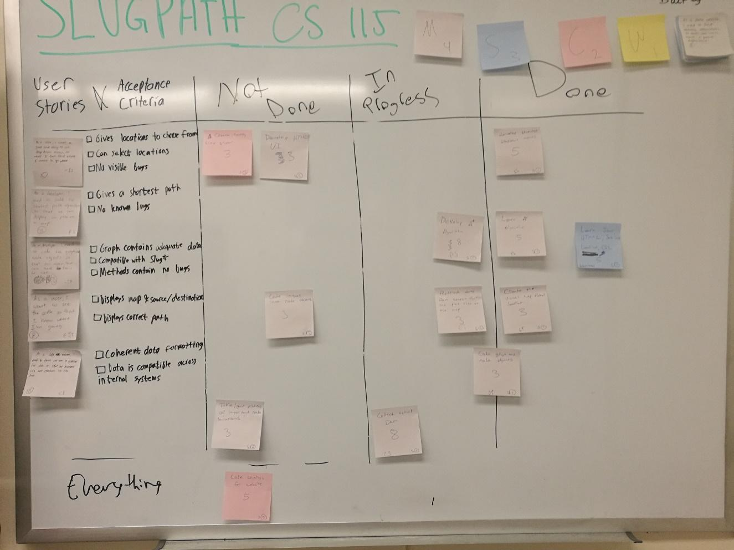

* User Story 1: As a javascript developer, I need to develop the shortest path algorithm so that we can display the shortest path on a visualized map.

User Story 1 Tasks

1. Learn and develop A* algorithm -In Progress-
2. Code Node and Graph objects -Completed-
3. Develop usable dropdown menu to select locations -Completed-

* User Story 2: As a data manager, I want node and edge data so that I can organize our data efficiently .

User Story 2 Tasks

1. Learn how to make a viable database structure -Completed-
2. Create all database objects by node and edge classification -Completed-
3. Collect location data -In Progress-

* User Story 3: As a user, I want to see the path so that I know where I am going.

User Story 3 Tasks

1. Create the visual map through Leaflet -Completed-

**Work completion rate:**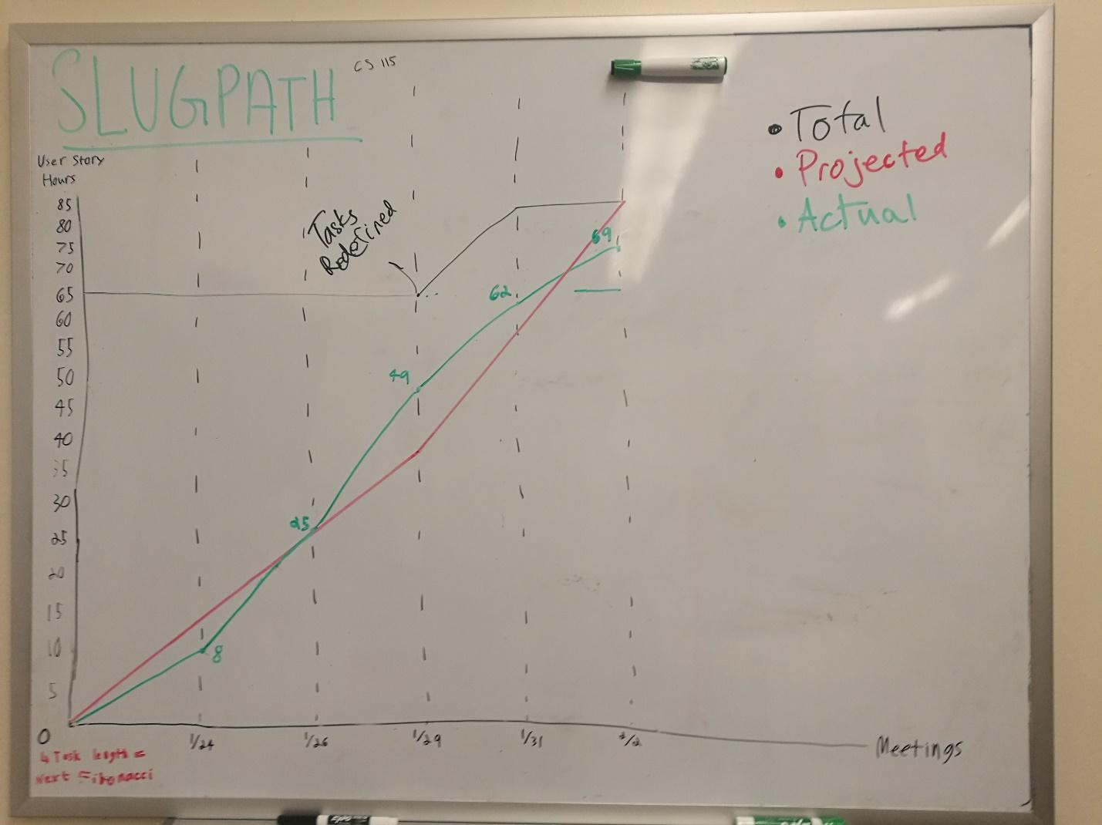

User stories completed 1.

Total number of ideal work hours: 80 hours

Actual number of hours worked: 69 hours

Total number of days in Sprint 1: 10